Module 11 – EOQ

Exploratory Data Analysis

*In this section, you should perform some data analysis on the data provided to you. Please format your findings in a visually pleasing way and please be sure to include these cuts:*

* *Make line graphs showing the following data over time:*
  + *Sales*
  + *Unit Purchase Cost*
  + *Fixed Order Cost*
* *Use a forecast method to determine annual demand for 2025 to use for our model*
  + *Naïve*
  + *Moving Average / Weighted Moving Average*

**

* + *Linear Regression*
  + *Exponential Smoothing*
* *For costs, use a similar/different method. Otherwise, a simple overall average is fine.*

Model Formulation

*Write the formulation of the model into here prior to implementing it in your Excel model. Be explicit with the definition of the decision variables, objective function, and constraints. Please restate the variables in the algorithm (i.e. D = Annual Demand)*

Min: DC + (D/Q)\*S + (Q/2)\*(C\*I)

Q ≥ 1

D = 16859

C = $45.43

S = $165.39

I = 20%

Model Optimized for Minimizing Costs with Optimal Order Quantity

*Implement your formulation into Excel and be sure to make it neat. This section should include:*

* *A screenshot of your optimized final model (formatted nicely, of course)*
* *A text explanation of what your model is recommending*

**

The model is recommending that if we want to fulfill an annual demand of 24995 units, with established unit costs, fixed order costs, and inventory holding costs, our EOQ should be 744 units.

* *Make a “sawtooth chart” for 2025, see below for reference. Assume you start with year with your EOQ Quantity like it has below*

*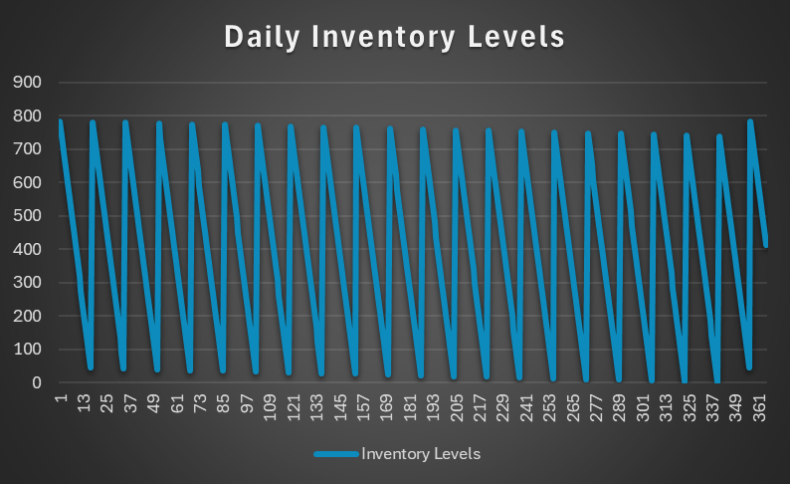*

Model with Stipulation

*Please copy the tab of your original model before continuing with the next part to avoid messing up your original solution.*

*Implement the below EOQ extension, EOQ with planned backorders. We have added 2 new variables: A = shortage cost & b = planned back orders. Restate the previous variables with these new ones please. Note, you’ll need to solve for both Q\* and b\* here to get the optimal solution. You should start Q out as the EOQ from the previous section and b as 0. Also, note that this algorithm does not include `D \* C` as it’s not relevant to this analysis*

**

**

*Lastly, do the following:*

* *Explain why you may include planned backorders (i.e. plan to accept purchases when out-of-stock such that some customers will wait for their purchase). Please think critically prior to doing any searches for why*

Because this allows us to drive down inventory holding costs, if we already know how much we are going to sell we know the exact quantity to order.

* *Make a similar “sawtooth chart” with the results here. Note, it will be very similar as before, but inventory will go below 0 before replenishing*

*